## **Lab 01: Getting Started with Translation Builder**

**Overview**: In this lab, you will learn how Translations Builder together with Power BI Desktop to build multi-language reports for Power BI. You will start by downloading a PBIX project file named **TB-Lab01.pbix** and opening it in Power BI Desktop. Once you have opened **TB-Lab01.pbix,** you will launch Translations Builder and practice by moving through the steps to add metadata translations and report label translations. At various milestones in this lab, you will be required to publish **TB-Lab01.pbix** from Power BI Desktop to the Power BI Service so you can test how the translations you’ve added appear to users when loaded using different languages and cultures.

**Prerequisite 1**: To complete this lab, you will need a Power BI workspace where you have appropriate permissions to publish project from Power BI Desktop to test your work. This workspace must also be associated with a Premium capacity as indicated by the diamond image (see below) displayed after the workspace name. This is required because Power BI translations do not load properly for reports tht are running in workspaces associated with the shared capacity.

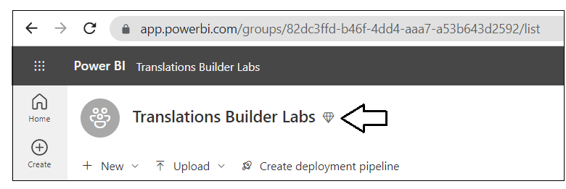

**Prerequisite 2**: This lab assumes you’ve already installed Translations Builder. If you haven’t installed Translations Builder yet, you must follow steps in the [Translations Builder Installation Guide](https://github.com/PowerBiDevCamp/TranslationsBuilder/blob/main/Docs/Installation%20Guide.md) before continuing with these lab exercises.

### Exercise 1: Creating and Testing Metadata Translations

In this exercise, you will begin by downloading a PBIX file which already has a simple data model and a single page report. You will then publish the project to the Power BI Service to set up a process whereby you can test out how your translations appear to report consumers.

1. Download the PBIX starter file named **TB-Lab01.pbix** from the following link

<https://github.com/PowerBiDevCamp/TranslationsBuilder/raw/main/Labs/StarterFiles/TB-Lab01.pbix>

1. Create a new folder on your local hard drive for these lab exercises such as **C:\DevCampLabs\**.

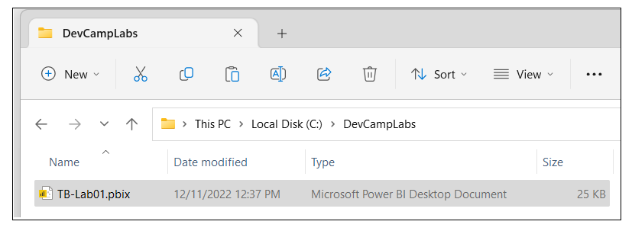

1. Copy **TB-Lab01.pbix** into the lab folder and then open it in Power BI Desktop to examine the report inside.

1. While in Report view, examine the **Fields** list to see the tables, columns and measure that are not hidden.

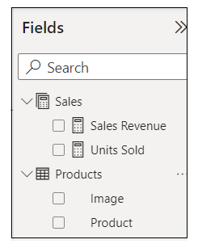

1. Now, navigate to Model view so you can see the entire data model including the columns hidden from Report view.

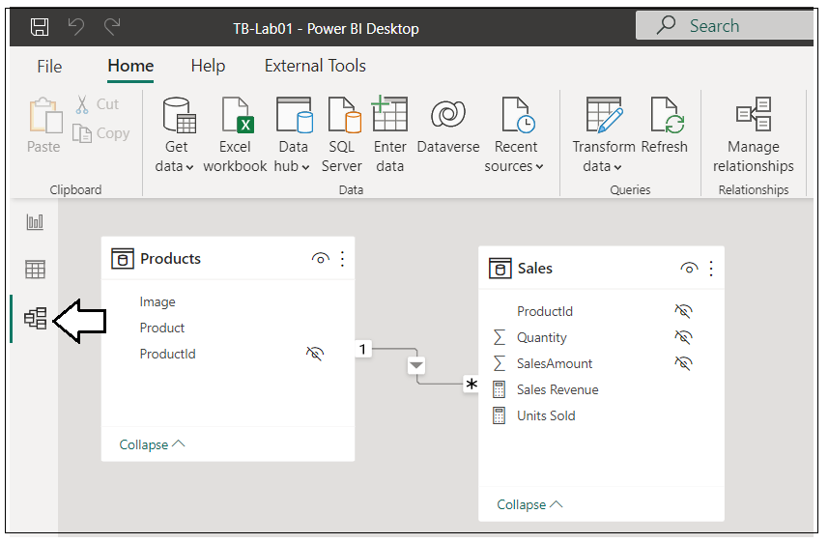

1. Navigate to Data view and examine the rows of the **Products** table.

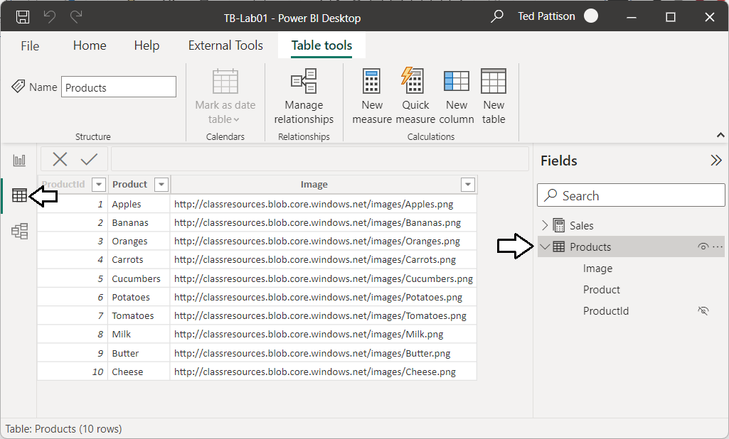

Now you are going to publish the TB-Lab01.pbix project to your test workspace in the Power BI Service.

1. Navigate to the **Home** tab and then click the **Publish** button.

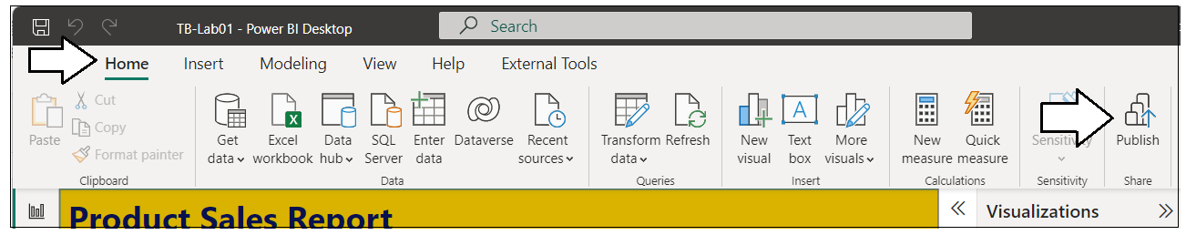

1. When prompted by the **Publish to Power BI** dialog, choose your test workspace and then click **Select**.

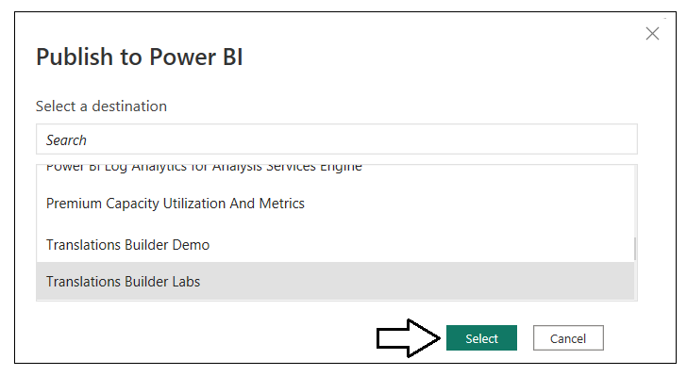

1. Once you see **Success!**, click **Open ‘TB-Lab01.pbx’ in Power BI** to view the report in the Power BI Service.

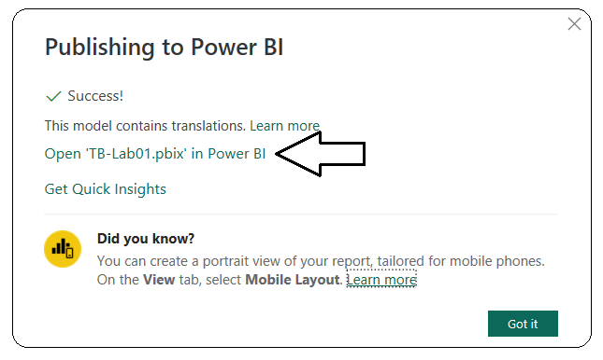

1. The report named TB-Lab01 should appear like the report in the screenshot below.

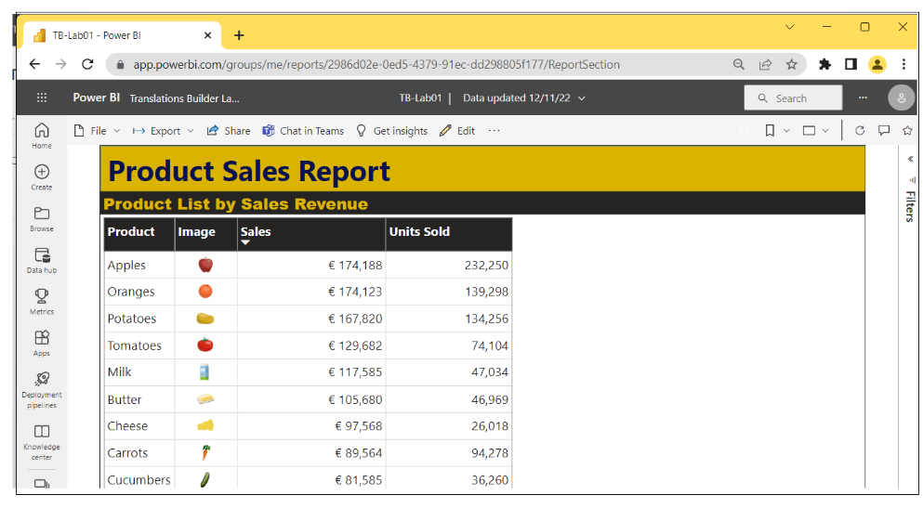

Now you are setup to follow this workflow: (1) make changes in Power BI Desktop, (2) publish the project, (3) check your work

It’s time to begin using Translations Builder to begin adding translations to the **TB-Lab01.pbix** project.

1. Return to Power BI Desktop, navigate to the **External Tools** tab and launch **Translations Builder**.

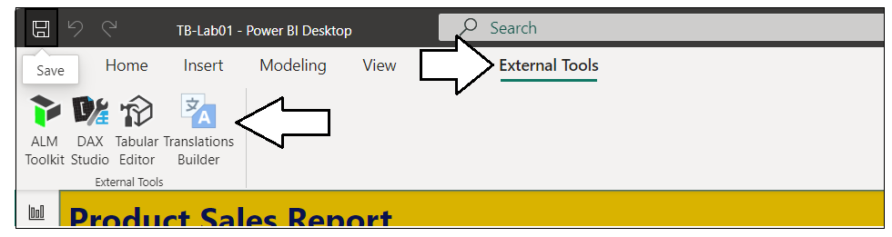

1. Translations Builder should start and load the data model for **TB-Lab01.pbix** as shown in the following screenshot.

1. The Dataset properties section provides details about the connection and the PBIX project file.

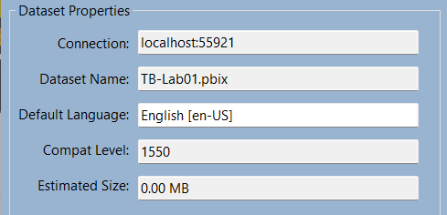

1. The grid on the bottom of the page display a row for each non-hidden dataset object in the data model.

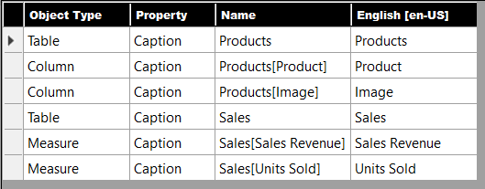

Tables, columns and measures that are hidden from report view in the data model are not displayed. You don’t need to translate them.

1. Click the **Add Language** button to add your first secondary language.

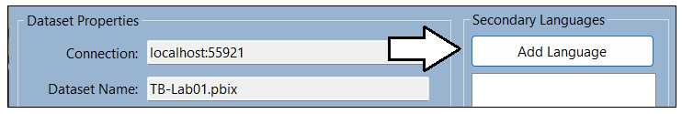

1. Select **Spanish [es-ES]** and click **Add Language**.

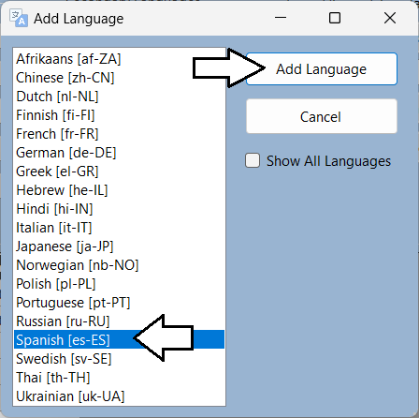

1. You should now see that **Spanish [es-ES]** appears the first language in the **Secondary Languages** list.

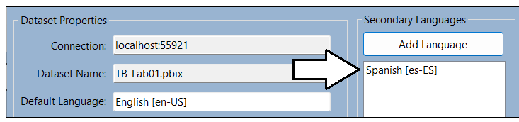

1. You will also notice that a new column has been added for Spanish translations.

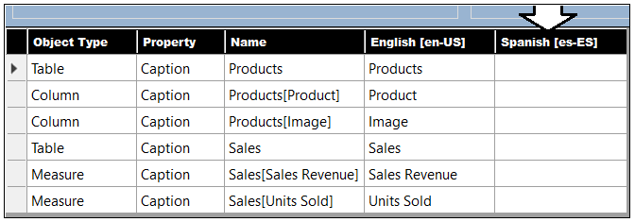

1. Locate the row for the **Products** table and click on the cell for the **Spanish** column. It should turn blue when selected.

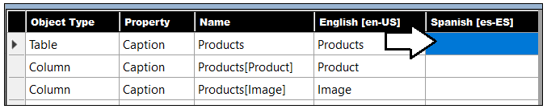

1. Type Hello World. You should see that you can start typing in a translation select that is selected to add a translation.

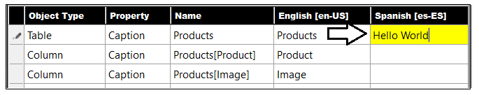

1. Click the **ENTER** key to save your changes to the cell and to move to the cell below.

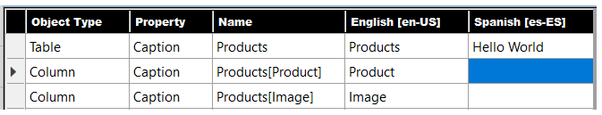

1. Now, type another word and press ENTER repeatedly to experiment adding text to all cells within a column.

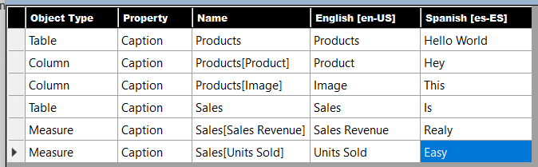

The point of the last few steps has been for you to become comfortable with the translation editing experience. You can see the grid provides a editing experience similar to working with an Excel worksheet. You can even use the {F2} key to move a cell into edit mode.

1. Now edit the translations in the Spanish columns with better translated values. Use the following translations.
   1. For the **Products** table, enter the Spanish translation of **Productos**.
   2. For the **Product** column, enter the Spanish translation of **Producto**
   3. For the **Image** column, enter the Spanish translation of **Imagen**.
   4. For the **Sales** table, enter the Spanish translation of **Ventas**.
   5. For the **Sales Revenue** measure, enter the Spanish translation of **Ingresos Por Ventas**.
   6. For the **Units Sold** measure, , enter the Spanish translation of **Unidades Vendidas**.
2. When you are done with your edits, the Spanish translations should match the following screenshot.

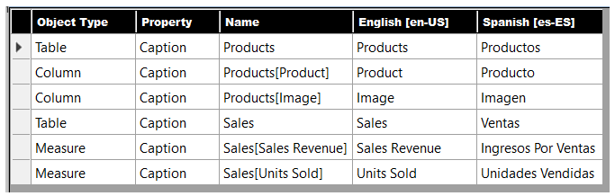

1. Xxxx

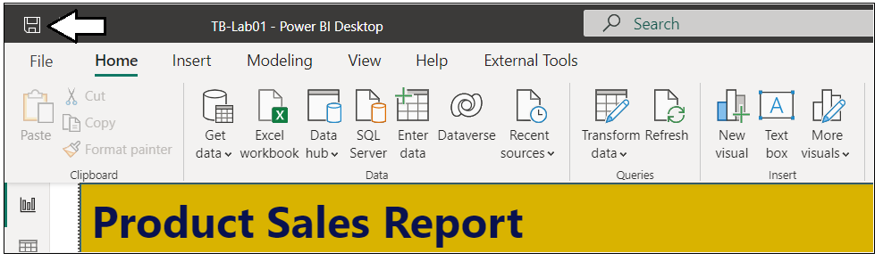

It’s easy to forget to save your changes in Power BI Desktop. Don’t forget.

1. Xx

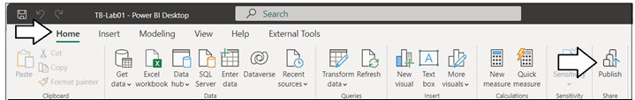

1. X

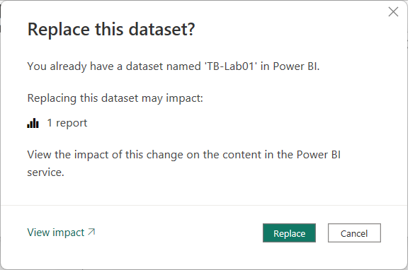

1. Xxx

1. Xxx

1. Xx

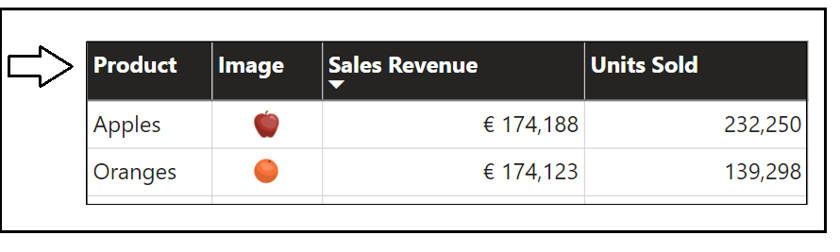

1. X

/?language=es-ES

1. X

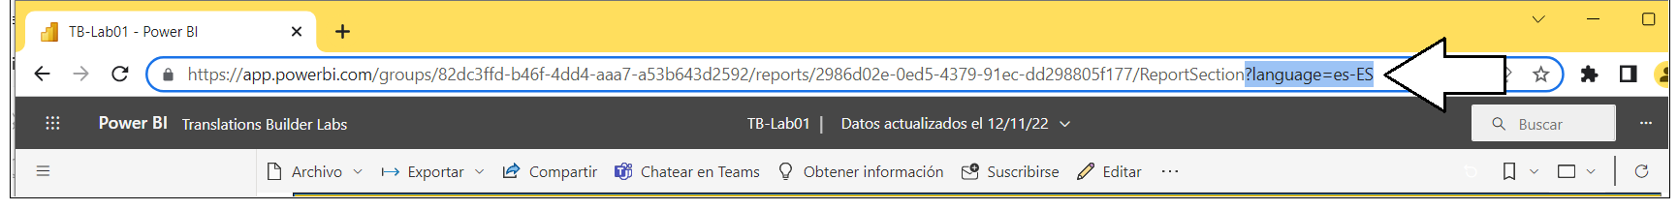

1. X

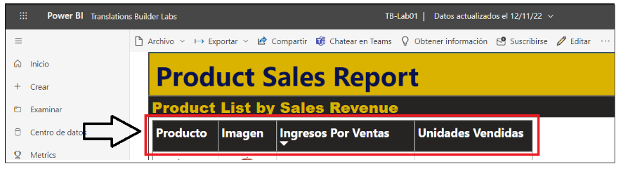

1. xxx

### Exercise 2: Generating Machine Translations

This is

**Key**: a75b371ce1fc402ca84a05732cfcff27

**Location**: eastus2

xx

### Exercise 3: Creating and Testing Report Label Translations

In this exercise ddddd

1. Rub your belly
2. Tap your forehead